厦门迪太进出口有限公司
XIAMEN DITAI IMP.& EXP. CO.,LTD
地址：中国厦门禾祥西路鸿升大厦8A
8FL, Hongsheng Building, West Hexiang Road, Xiamen, Fujian, China
TEL:0592-26808108 FAX:0592-2680880 E-mail: irene.zhang@xmditai.com

Manganese Sulfate Mono CAS 10034-96-5

Manganese Sulfate Mono CAS 10034-96-5
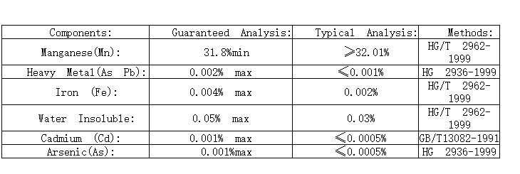
Manganese Sulfate Mono CAS 10034-96-5is Used as a porcelain glaze, as a fertilizer additive and as a catalyst. It is added to soils to promote plant growth, especially of citrus crops. It is a good reducing agent for manufacturing paints, varnish driers. It is used in textile dyes, fungicides, medicines and ceramics. In foods, it is used as a nutrient and dietary supplement. It is also used in ore flotation, as a catalyst in viscose pro- cess and in synthetic manganese dioxide. In veterinary medicine, it is used as a nutritional factor and in the prevention of perosis in poultry.

EINECS No.:2 32-089-9

CAS No.: 10034-96-5

Apperance: pinkish powder or granular

H.S. Code: 2833.299090

31.8% min Manganese Sulphate powder

Detailed specification sheet

ITEM | UNIT | SPECIFICATION
Mn | min | 31.8
Pb | max | 0.001%
As | max | 0.0005%
Cd | max | 0.001%
Ni | max | 100ppm
Co | max | 100ppm
Fe | max | 0.004%
Cl | max | 0.005%
PH | 5.0-6.5 | 5.5
Water Insoluble | max | 0.05%
Fineness (pass 250 um sieve | min | 95%
31.%min Manganese Sulphate granule
ITEM | UNIT | SPECIFICATION
Mn | min | 31.5%
Pb | max | 0.001%
As | max | 0.0005%
Cd | max | 0.001%

Company Information

Xiamen Ditai Chemicals Co., Ltd is a professional chemical company in China. We are proud our quality chemcials and service was approbated by the clients in the worldwide.





